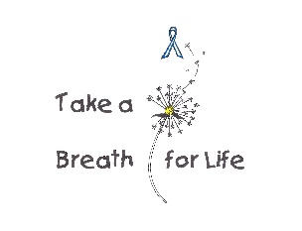 **2018 TAB4L Student Poster Contest Rules / Entry Form**

1. The poster must be original work.
2. The theme of the poster should encourage Lung Health while advertising that November is lung cancer awareness month and a white ribbon must be included in the design
3. The artist’s first and last name must appear clearly on the lower right-hand corner of the poster. Entry form must be attached to the back of poster
4. Entries must be on 8 1/2” X 11” paper
5. Artist must allow the poster to be used for publication
6. Any artistic medium may be used, such as markers, crayons, paint pens, watercolor, ink, acrylic and colored pencils
7. Collages are not acceptable. DO NOT GLUE any items onto your poster
8. Computer or photo-generated art or printing is not acceptable
9. Posters must not be matted, mounted, laminated, framed or folded
10. Only one poster entry per student
11. Two groups are eligible. First group is grades K, 1 and 2. Second group is for grades

3, 4 and 5. There will be three winners for each group.

1. Decisions of the judges are final. (Judges criteria includes clarity of theme, visual effectiveness, originality and over all appeal).
2. Posters can be delivered to the Lower Grand Stand / Carousel Banquet Facility located at the Hamburg Fair Grounds Friday November 9th between 5:00 and 7:00 pm or mailed to 8448 State Rd. Colden NY 14033 and received not later than Thursday November 8th.
3. Winners will be announced Saturday November 10th at 3:00 pm at the Lower Grand Stand during our Lung Cancer Awareness Event. 5K, Theme Baskets, Live Music, Food, Great family event!
4. Posters will become the property of the TAB4L Foundation.

For questions about the fundraiser or the poster contest call contest chair, Jessi Gavin at 716 319-8328

|  |
| --- |
| **Lung Cancer Awareness**  **Student Poster Contest Entry Form** |
| Student Name:  _______________________________________________________________________________  Phone No.: _______________________________________________________________________  Email: __________________________________________________________________________  School Name & Grade:  _______________________________________________________________________________  I certify that this poster is the original artwork of this student & that it may be published and used by the TAB4L Foundation.  ___________________________________________________________________________________________________  Parent or Guardian Signature  ___________________________________________________________________________________________________  Student Signature |